Payment Hold

Summary
When processing a mail order prescription there may be an issue with the member’s payment method that blocks processing. This functionality allows the member to update the payment method and send the order to be processed.

Parameters

Mail order
{"status":"\"ELIGIBLE\"","selfServeOption":"\"PAYMENT_HOLD\"","priority":"1","callToAction":"\"N\"","displayValue":"\"Change Payment Method\"","heroAction":"\"N\""}

Filters

Mail order
(fillStatusReasonCode == 54)

Caremark.com screenshots
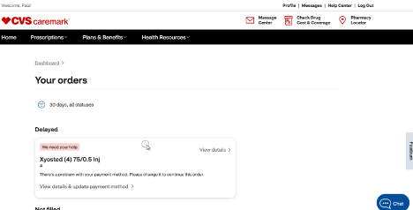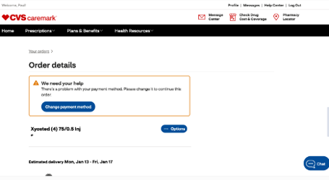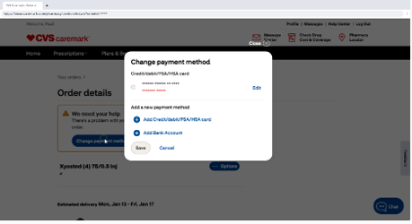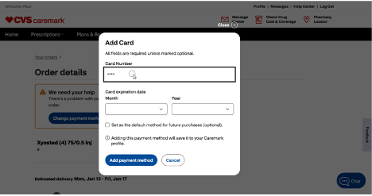
A
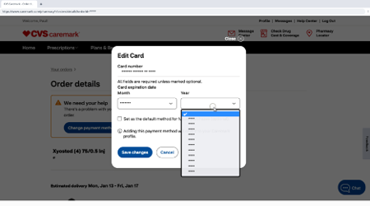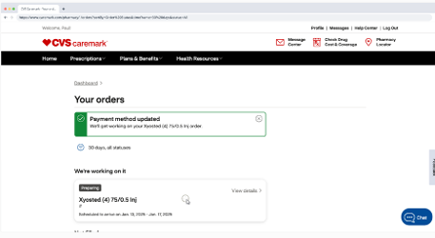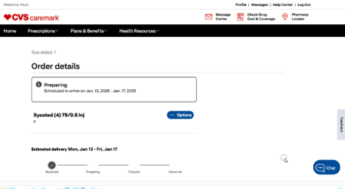

Experience API information
Experience ID (Mail order) - ca1e0a67-0404-4019-ad2c-887479281512
https://apiforge.cvshealth.com/apis/editor/Gateway-Specs/b2b-clientapi-experience-v1/1.0.0-cmk-high-cost-hold

